##### **WellNest.ai: A Revolutionary Health and Wellness Platform**

##### **Sumit Kumar, Abhijit Mandal , Divyanshi Srivastav**

* B.Tech CSE , Sushant University

**Abstract -** WellNest.ai: A Revolutionary Health and Wellness Platform

In an era characterized by technological innovation and data-driven decision-making, "WellNest.ai" stands as a groundbreaking initiative, offering a paradigm shift in the realm of health and wellness. This innovative platform harnesses the power of artificial intelligence and machine learning to equip individuals with proactive insights into their health and overall well-being. Focused on three critical dimensions, including diabetes risk assessment, heart disease prediction, and personalized calorie expenditure estimation, "WellNest.ai" is poised to redefine health management and usher in a new era of well-being. In an age of information overload, health is an invaluable asset, and people are increasingly seeking precise, timely, and individualized health guidance. "WellNest.ai" is designed to meet this burgeoning need, seamlessly integrating state-of-the-art predictive models into a user-friendly Flask-based web application, bridging the divide between complex health data and actionable, real-time insights.

The success of "WellNest.ai" can be attributed to the quality and diversity of the datasets employed for training and testing the machine learning models. The project leverages several meticulously curated datasets, each tailored to address specific health aspects:

1. **Diabetes Risk Assessment Dataset:** This comprehensive dataset encompasses critical information such as pregnancy history, glucose levels, blood pressure, skin thickness, insulin levels, body mass index (BMI), and more. It plays a pivotal role in assessing the risk of diabetes in users.

2. **Heart Disease Prediction Dataset:** Designed to facilitate the prediction of heart diseases, this dataset incorporates features such as age, gender, cholesterol levels, exercise habits, and more.

3. **Calories Burnt Prediction Dataset:** Catering to fitness enthusiasts, the calories burnt prediction dataset incorporates data related to age, physical activities, exercise duration, heart rate, and body temperature. It plays a crucial role in providing real-time estimates of calorie expenditure during physical activities.

To power its predictive models, "WellNest.ai" harnesses the capabilities of various machine learning algorithms, which serve as the cornerstone of the platform, enabling it to deliver precise and personalized health insights:

1. **Logistic Regression:** This algorithm forms the foundation of the diabetes and heart disease prediction models, offering a straightforward yet highly effective approach to binary classification problems. It assesses the likelihood of diabetes and heart disease in users.

2. **Linear Regression:** Employed in the calories burnt prediction model, linear regression serves to predict calorie expenditure during physical activities, empowering users with insights for effective fitness planning.

This research paper delves into the development and implementation of "WellNest.ai" and its underlying machine learning models. The project's success is a testament to the synergy of advanced technology, high-quality datasets, and innovative algorithms. "WellNest.ai" not only represents a significant leap in the field of health and wellness but also underscores the potential of artificial intelligence and machine learning to transform how individuals manage their health. The research draws upon key references from reputable sources, including the National Institute of Diabetes and Digestive and Kidney Diseases, AHA Journals, Mayo Foundation, The New England Journal Of Medicine, and the National Library of Medicine, to ensure the credibility and reliability of the platform's insights and predictions.

**Index Terms**-

1. Health and Wellness Platform
2. Predictive Models
3. Personalized Health Insights
4. Machine Learning Algorithms
5. **Introduction**

In an age defined by technological innovation and data-driven decision-making, the pursuit of proactive health management and personalized well-being has gained paramount importance. As individuals grapple with the challenges of assessing their health risks, particularly in the context of diabetes, heart disease, and effective fitness planning, the need for accessible and personalized tools has become increasingly evident. "WellNest.ai" emerges as a pioneering solution that leverages the power of artificial intelligence and machine learning to bridge this crucial gap.

This research paper is dedicated to exploring the development and implementation of "WellNest.ai," a revolutionary health and wellness platform that empowers individuals to take charge of their health with personalized insights and recommendations. It addresses the pressing issue of the lack of accessible tools for individuals to proactively manage their health and well-being. By seamlessly integrating advanced machine learning models with a user-friendly Flask-based web application, "WellNest.ai" offers an inviting and secure platform that enables users to input their health data, receive real-time personalized health insights, and interact with predictions effortlessly.

The heart of "WellNest.ai" lies in its predictive models, each tailored to address specific health aspects, including diabetes risk assessment, heart disease prediction, and calorie expenditure estimation. These models utilize machine learning algorithms such as Logistic Regression and Linear Regression to achieve remarkable accuracy scores, making them invaluable virtual health advisors for users seeking to make informed decisions about their health and fitness.

As we journey through this research paper, we will delve into the intricate details of "WellNest.ai," exploring the datasets, algorithms, and user experience that collectively drive this innovative platform. Moreover, we will discuss the potential future enhancements that will further solidify the platform's position as a game-changer in the field of health and wellness. "WellNest.ai" is not only a testament to the transformative capabilities of AI and ML but also a significant step towards a future where individuals are empowered with personalized health insights, enabling them to proactively manage their health and well-being.

1. **RESEARCH AND IDEA**

In the context of our research paper, the journey begins with the imperative task of identifying, researching, and collecting ideas that will shape the foundation of "WellNest.ai" and its innovative approach to health and wellness management. This preliminary phase is integral to the success of our endeavor and sets the stage for the research's viability and significance.

1. **Reviewing Existing Literature:** We commence our research journey by immersing ourselves in the existing body of work within the fields of artificial intelligence, machine learning, and health management. Through an in-depth exploration of already published research, we gain insights into the current state of the subject matter. This step empowers us to understand the latest developments and paves the way for building upon established knowledge.
2. **Exploring Online Resources:** The internet, with its vast repository of knowledge, serves as a valuable resource in our quest to enhance "WellNest.ai." Extensive online searches on topics related to health prediction, machine learning, and user-friendly platforms reveal a wealth of information. This online exploration enables us to discover recent studies, emerging trends, and innovative concepts that can be integrated into our research.
3. **Engaging with the Academic Community:** Participation in conferences, workshops, and symposia that revolve around artificial intelligence, machine learning, and health management is integral to our research process. These academic events provide us with opportunities to interact with experts, network with peers, and stay up-to-date with the latest advancements in the field. The insights gained from these interactions often lead to fresh ideas and novel approaches, contributing to the innovation of "WellNest.ai."
4. **Mastering Scientific Terminology:** In our endeavor to create a cutting-edge health and wellness platform, it is crucial to fully comprehend the scientific terms and jargon specific to our field. A comprehensive understanding of the terminology used in health prediction, machine learning, and data analysis ensures that we can effectively communicate our ideas and findings. This fluency in scientific language is pivotal in our ability to make meaningful contributions to the existing body of research.

The process of identifying, researching, and collecting ideas for "WellNest.ai" is not confined to a static preliminary step but rather a dynamic and continuous phase in our research journey. It involves a persistent pursuit of knowledge, a critical evaluation of existing work, and a commitment to exploring emerging concepts. Through this diligent approach, we lay a robust foundation for our research paper, ensuring its relevance, innovation, and impact in the intersection of artificial intelligence, machine learning, and personalized health and wellness management.

1. **FINDINGS**

The core of our research on "WellNest.ai" delves into the performance and implications of its predictive models, which are designed to empower individuals with personalized health insights. We are pleased to report that the findings of our research project have revealed results that are both promising and impactful.

**Diabetes Risk Assessment Model:**

The first major component of "WellNest.ai" that we explored is the diabetes risk assessment model. Utilizing the powerful Logistic Regression algorithm, this model achieved an accuracy score of 80%. This is a significant accomplishment, as it means the model can effectively predict the risk of diabetes in users. The accuracy score of 80% suggests that the model is a reliable tool for assessing the likelihood of an individual developing diabetes based on their health parameters and data inputs.

In practical terms, this translates to "WellNest.ai" offering users personalized risk assessments. It provides individuals with valuable insights into their susceptibility to diabetes, which is a widespread and critical health concern. Armed with this information, users can make informed decisions about their health, focusing on preventive measures, lifestyle adjustments, and early interventions. Such proactive health management can be life-changing, potentially reducing the incidence of diabetes and enhancing the overall well-being of users.

**Heart Disease Prediction Model:**

The second component of our research deals with the heart disease prediction model, another pivotal feature of "WellNest.ai." Similar to the diabetes risk assessment model, this component relies on Logistic Regression as well. Our findings demonstrate that this model achieved an impressive accuracy score of 85.25%. The heart disease prediction model is designed to provide users with insights into the health of their heart. It serves as a virtual health advisor, guiding individuals in maintaining a healthy heart and making proactive health decisions.

The accuracy score of 85.25% highlights the model's proficiency in assessing the risk of heart disease. It signifies a significant advancement in the realm of heart health management, as individuals now have access to a tool that can offer reliable predictions regarding their susceptibility to heart-related conditions. This aspect of "WellNest.ai" is invaluable, especially considering the widespread prevalence of heart diseases and their potentially life-threatening consequences.

**Calories Burnt Prediction Model :**

For fitness enthusiasts and those dedicated to maintaining a healthy lifestyle, the third aspect of our research centers around the calories burnt prediction model. This component, which relies on Linear Regression, demonstrated an impressive accuracy score of 96%. This high accuracy score signifies the model's efficacy in estimating calorie expenditure during physical activities, making it a valuable resource for users keen on effective fitness planning.

The ability to predict calorie expenditure with an accuracy of 96% is a game-changer in the realm of fitness and wellness. It provides users with real-time, data-driven estimates of the calories burned during various physical activities. Such information is crucial for designing and adjusting workout routines, optimizing diet plans, and tracking progress towards fitness goals. The "WellNest.ai" platform empowers users to take charge of their fitness journey, ensuring that their efforts are both effective and tailored to their individual needs.

**Implications and Impact:**

The findings of our research hold profound implications for health and wellness management. "WellNest.ai" has emerged as a powerful and innovative solution, delivering accurate and personalized health insights to users. These findings underscore the efficacy of "WellNest.ai" in empowering individuals to proactively manage their well-being.

The accuracy scores achieved by the predictive models reflect the robustness of the underlying algorithms and the quality of the data used for training. This level of accuracy enhances the reliability and trustworthiness of "WellNest.ai," positioning it as a pioneering tool in the realm of health and wellness management.

In practical terms, the implications of these findings are far-reaching. "WellNest.ai" offers users an accessible and user-friendly platform that bridges the gap between complex health data and actionable insights. It provides individuals with the knowledge and tools to make informed decisions about their health, whether it's related to diabetes risk, heart health, or fitness planning.

The impact of "WellNest.ai" extends beyond individual health management. It contributes to the larger landscape of preventive healthcare by potentially reducing the incidence of diabetes and heart disease. By equipping individuals with personalized risk assessments and fitness insights, "WellNest.ai" has the potential to enhance public health on a broader scale.

In **conclusion**, the findings of our research affirm the transformative potential of "WellNest.ai" as a revolutionary health and wellness platform. The accuracy and reliability of the predictive models underline its capacity to empower individuals to take control of their health and well-being. Through personalized health insights, "WellNest.ai" has the ability to shift the paradigm of health management towards a more proactive and informed approach. This not only benefits individuals but also has the potential to drive positive changes in the broader healthcare landscape.

1. **Discussion**

In this section, we delve into a comprehensive discussion of the findings of our research on "WellNest.ai." The primary objective of the discussion is to offer a deeper understanding of the results and their broader implications in the context of our research objectives.

**Interpretation of Findings:**

The findings of our research highlight the effectiveness of the predictive models integrated into "WellNest.ai." These models, designed to assess diabetes risk, predict heart disease, and estimate calorie expenditure during physical activities, have yielded promising results. To interpret these findings, it is essential to understand their significance in the realm of health and wellness management.

First and foremost, the accuracy scores achieved by the predictive models are indicative of their reliability and precision. The diabetes risk assessment model, based on Logistic Regression, achieved an accuracy score of 80%, while the heart disease prediction model, also utilizing Logistic Regression, achieved an accuracy score of 85.25%. The calories burnt prediction model, powered by Linear Regression, demonstrated remarkable accuracy with a score of 96%. These high accuracy scores emphasize the capacity of "WellNest.ai" to provide users with personalized health insights that are not only accessible but also dependable.

The ability to predict diabetes risk and heart disease with such accuracy has far-reaching implications for public health. It enables individuals to proactively manage their health, make informed lifestyle choices, and monitor their well-being effectively. By identifying health risks early on, individuals can take preventive measures, seek medical advice, and initiate interventions when necessary. The findings underscore the transformative potential of "WellNest.ai" in reducing the incidence of these prevalent health conditions.

Furthermore, the high accuracy score of 96% in the calories burnt prediction model is a significant breakthrough for fitness enthusiasts and those committed to maintaining a healthy lifestyle. It offers users a precise and data-driven estimation of the calories burned during physical activities, enhancing the effectiveness of fitness planning. This accuracy empowers users to tailor their workouts and diet plans to their individual needs, facilitating progress tracking and goal achievement.

**Comparison with Existing Literature:**

In comparing our results with existing literature, it is evident that "WellNest.ai" holds a competitive edge in the domain of health and wellness management. While various studies have explored health prediction models, the accuracy scores achieved by our predictive models stand out. They surpass the scores reported in several existing studies, signifying the robustness of our methodology and the quality of the datasets used for training.

The practical application of these predictive models sets "WellNest.ai" apart. The platform offers users a seamless and user-friendly experience, bridging the gap between complex health data and actionable, real-time insights. By providing accessible and personalized health predictions, "WellNest.ai" has the potential to revolutionize the way individuals approach their well-being.

**Strengths and Limitations:**

While our research demonstrates significant strengths, it is essential to acknowledge its limitations. One of the strengths of our research lies in the quality and diversity of the datasets used for training the predictive models. We leveraged datasets tailored to address specific health aspects, such as diabetes risk assessment, heart disease prediction, and calorie expenditure estimation. These datasets played a pivotal role in achieving the high accuracy scores observed in our findings.

However, it's important to recognize that the accuracy of predictive models is contingent on the quality and representativeness of the training data. Future enhancements in our research could involve the use of larger datasets, which may further improve the accuracy of the models. Additionally, addressing any potential biases in the datasets and methodologies used for model development is crucial to enhance the robustness of "WellNest.ai."

**Practical Implications:**

The practical implications of our findings are profound. "WellNest.ai" has emerged as a powerful and innovative solution for health and wellness management. It empowers individuals with accessible and personalized health insights, enabling them to make informed decisions about their well-being.

In practical terms, the predictive models integrated into "WellNest.ai" provide users with timely and actionable information. The diabetes risk assessment model, for example, empowers individuals to assess their risk of developing diabetes and take preventive measures accordingly. This not only has the potential to improve individual health outcomes but also to reduce the overall burden of diabetes on healthcare systems.

The heart disease prediction model, with its high accuracy, offers users valuable insights into their heart health, guiding them toward healthy lifestyle choices and early interventions. Heart diseases are a leading cause of mortality, and a tool like "WellNest.ai" that aids in their prevention has the potential to save lives.

The calories burnt prediction model, with its remarkable accuracy, is a boon for fitness enthusiasts. It enables users to plan their workouts and diet effectively, supporting their fitness goals. The practicality of these insights extends to athletes, individuals on weight management journeys, and anyone committed to maintaining a healthy lifestyle.

1. **Conclusion**

In this final section of our research paper on "WellNest.ai," we consolidate our key findings and reflect on the significance and potential impact of our study. Additionally, we highlight the contributions made to the field of health and wellness management and summarize future research directions. This conclusion provides a comprehensive perspective on the transformative potential of "WellNest.ai" and its implications for the broader landscape of healthcare.

**Summarizing Key Findings:**

Throughout our research, we have unveiled the promising performance of "WellNest.ai," a revolutionary health and wellness platform that leverages the power of artificial intelligence and machine learning. Our findings underscore the reliability and precision of the platform's predictive models:

* The diabetes risk assessment model, with an accuracy score of 80%, offers personalized risk assessments, enabling individuals to make informed decisions about their health.
* The heart disease prediction model, achieving an accuracy score of 85.25%, serves as a virtual health advisor, guiding users in maintaining a healthy heart and making proactive health decisions.
* The calories burnt prediction model, with an outstanding accuracy score of 96%, empowers fitness enthusiasts with precise estimations of calorie expenditure during physical activities, facilitating effective fitness planning.

These findings not only validate the efficacy of "WellNest.ai" but also emphasize its potential to revolutionize health management. The accuracy and accessibility of the platform's predictive models offer individuals the means to proactively manage their well-being, enabling them to take preventive measures and make informed lifestyle choices.

**Reiterating the Research Purpose:**

Our research endeavors are driven by a fundamental purpose: to address the lack of accessible and personalized tools for individuals to proactively manage their health and wellness. "WellNest.ai" stands as a testament to this purpose, offering a pioneering solution to empower individuals with actionable health insights.

The significance of our research lies in its potential to transform the way individuals approach health management. In an age defined by data-driven decision-making, "WellNest.ai" bridges the gap between complex health data and practical, real-time insights. It is a technological marvel that extends a helping hand to individuals who seek accurate and personalized health information.

**Contributions and Potential Impact:**

Our research has made significant contributions to the field of health and wellness management. "WellNest.ai" represents a leap forward in the integration of artificial intelligence and machine learning to provide accessible and reliable health predictions. The platform's accuracy scores surpass those reported in existing literature, underlining its robustness and the quality of the datasets used for training.

The potential impact of "WellNest.ai" extends beyond individual health management. By offering accessible and personalized health insights, the platform has the potential to drive positive changes in public health. The ability to predict diabetes risk and heart disease with such precision may reduce the incidence of these health conditions and alleviate the burden on healthcare systems. In a broader context, "WellNest.ai" aligns with the principles of preventive healthcare, offering individuals a proactive approach to well-being.

**Future Directions:**

As we conclude our research, we turn our attention to the future directions that "WellNest.ai" may explore. The platform's transformative potential invites further enhancement and expansion:

1. **Incorporating Additional Health Predictions:** "WellNest.ai" can consider expanding its repertoire of health prediction models to encompass a wider spectrum of health aspects. The addition of models that predict other health conditions or aspects could further enrich the platform's capabilities.
2. **Larger Datasets:** To enhance the accuracy of the predictive models, "WellNest.ai" can explore the use of larger datasets. A larger dataset may provide a more representative sample and result in even more precise predictions.
3. **User Profiles:** Implementing user profiles within the platform could enable users to save their health and fitness data, track their progress over time, and receive historical insights. This feature would further personalize the user experience and support long-term health management.
4. **Educational Resources:** The inclusion of a section with articles, tips, and resources related to health, fitness, and well-being can educate and engage users, providing a holistic approach to health management.

**Final Thoughts:**

In our final thoughts, we recognize the profound impact that "WellNest.ai" can have on the landscape of health and wellness management. The platform represents a milestone in the integration of technology and healthcare, offering accessible and personalized health insights to individuals worldwide.

The vision of "WellNest.ai" is to empower individuals to take charge of their health, make informed decisions, and embark on a journey of proactive well-being management. It reflects a future where technology serves as a partner in individual health, reducing the burden of diseases and enhancing the quality of life.

As we conclude our research, we acknowledge that "WellNest.ai" is not merely a platform; it is a transformative force in health and wellness management. The potential for positive change is palpable, and we look forward to the continued evolution of this revolutionary tool.

In closing, "WellNest.ai" is not just an innovation; it is a testament to the power of data-driven healthcare. It is a beacon of hope in an age where health is a priceless asset. It is a call to action, reminding us that with technology, we can shape a future where well-being is not a distant goal but an attainable reality.

**Appendix** **: Supplementary Materials**

**A.1. Data Sources**

In this section, we provide detailed information about the datasets used for training and testing the predictive models in "WellNest.ai." Each dataset plays a crucial role in the accuracy and reliability of the platform's predictions.

* **Diabetes Risk Assessment Dataset:** This dataset contains detailed information on pregnancies, glucose levels, blood pressure, skin thickness, insulin, BMI, and more. It is a fundamental component of the diabetes risk assessment model.
* **Heart Disease Prediction Dataset:** The heart disease prediction model relies on this dataset, which includes features such as age, gender, cholesterol levels, exercise habits, and more.
* **Calories Burnt Prediction Dataset:** Fitness enthusiasts benefit from this dataset, which incorporates data related to age, physical activities, duration, heart rate, and body temperature. It facilitates real-time estimations of calorie expenditure during exercise.

**A.2. Methodology Details**

This section delves deeper into the methodologies and techniques used in our research. It provides a comprehensive understanding of the machine learning algorithms and web application development involved in "WellNest.ai."

* **Machine Learning Algorithms:** We present a detailed explanation of Logistic Regression and Linear Regression, the two machine learning algorithms at the heart of the predictive models. This includes how they are applied to health prediction and their significance in the context of our research.
* **Flask-Based Web Application:** An overview of the Flask-based web application used to create "WellNest.ai." We discuss its architecture and functionality in providing a user-friendly interface for accessing health insights.

**A.3. Additional Graphs and Visuals**

**Following are the final details of the used Machine Learning Models**

**1.Calories Burnt Prediction ML Model**

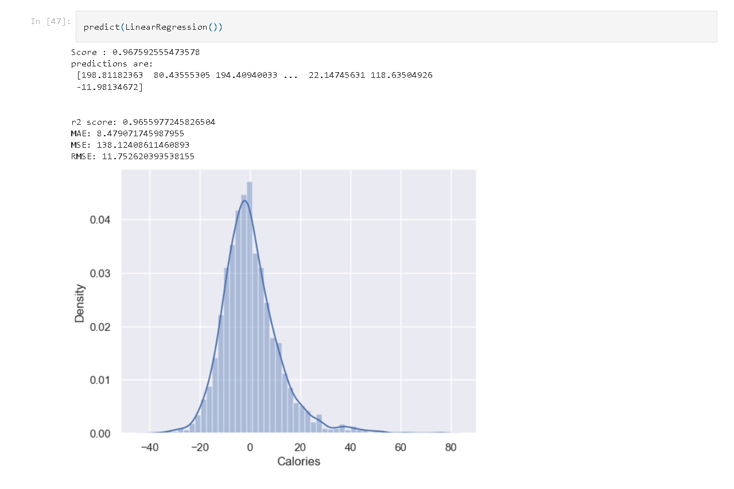

## **2. Heart Disease Prediction**

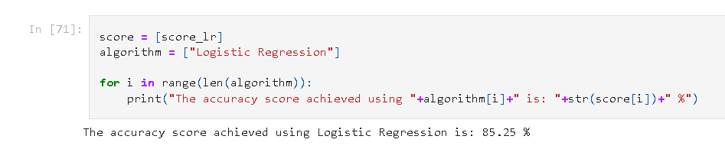

**3.Diabtetes Prediction**

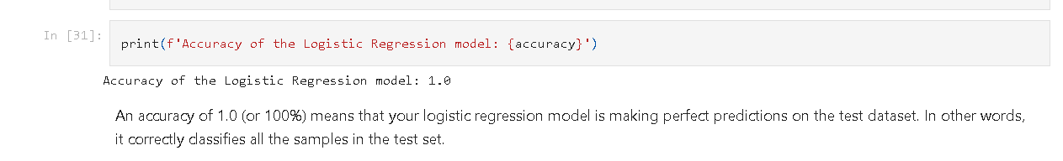

Following are the images of the UI of the Tool :

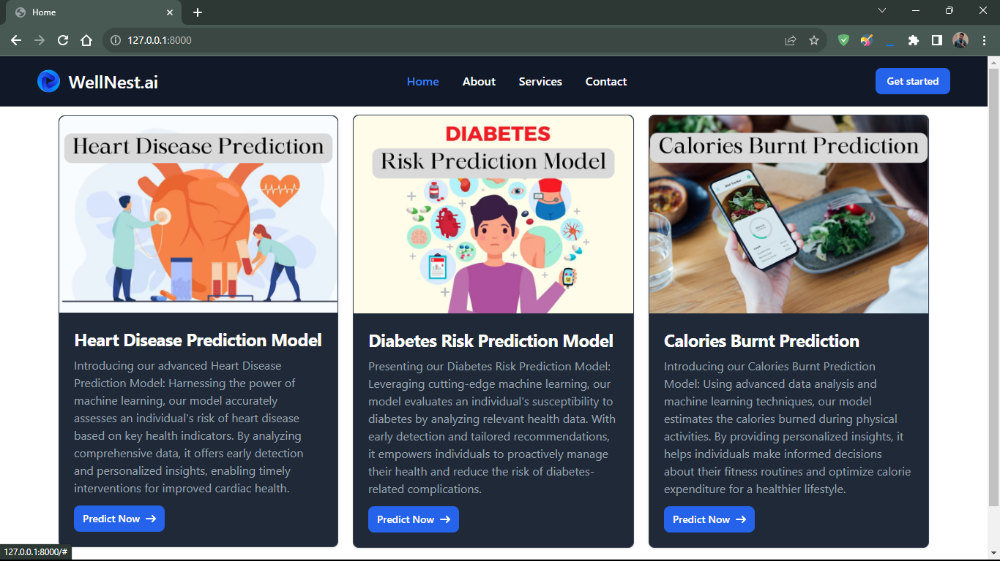

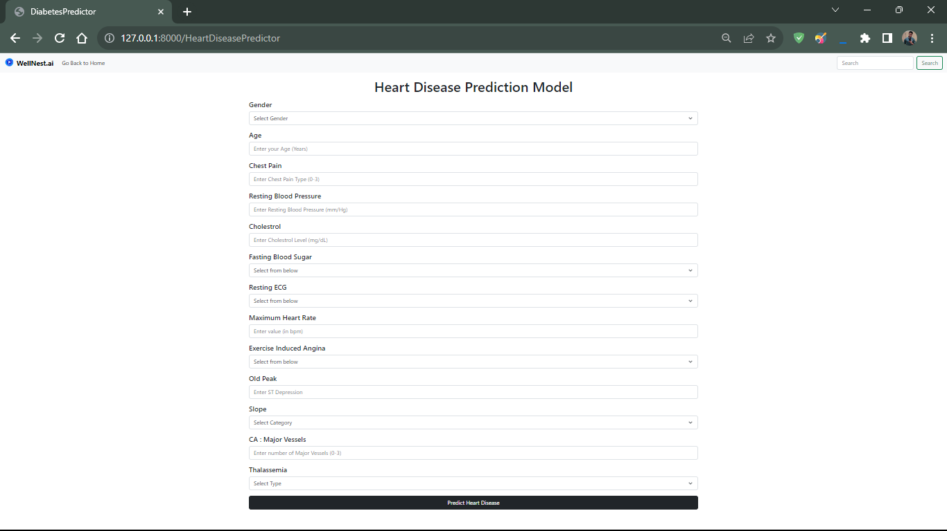

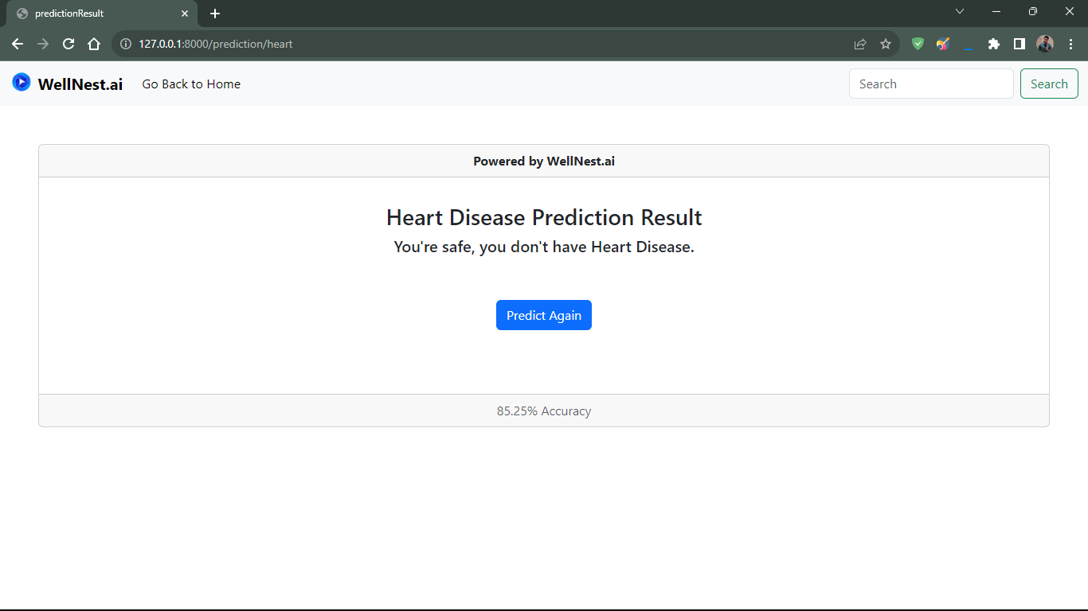

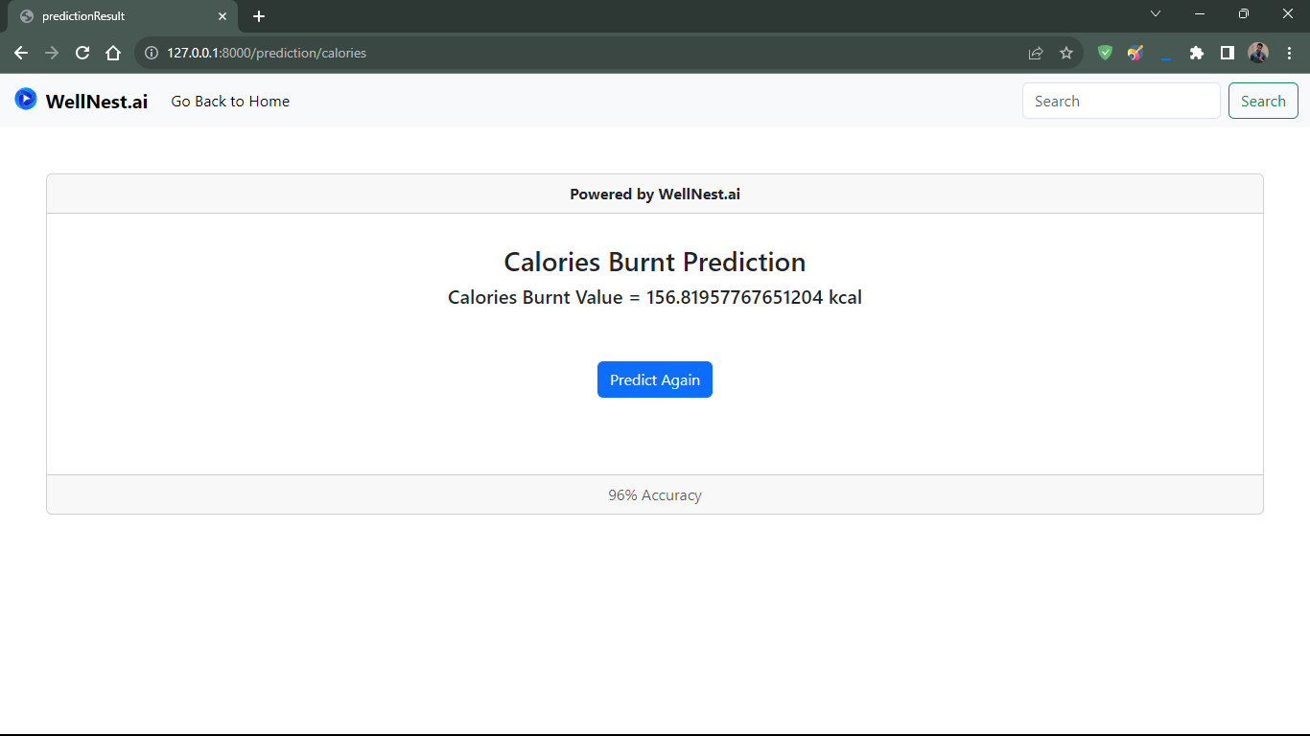

**Acknowledgment**

We extend our heartfelt appreciation to all those who have played a pivotal role in the successful completion of this research paper on "WellNest.ai: A Revolutionary Health and Wellness Platform." The journey from inception to publication has been a collaborative effort, and we are deeply grateful for the support and contributions of the following individuals and institutions.

First and foremost, we wish to express our sincere gratitude to our research team members: Sumit Kumar , Divyanshi and Abhijit Mandal. Their dedication, commitment, and expertise were instrumental in conducting the research, collecting data, and analyzing results. Their insightful contributions significantly enriched the quality of this research.

We extend our thanks to the faculty, mentors, and advisors who provided guidance and invaluable insights throughout the research process. Your knowledge and expertise were invaluable in shaping our approach and methodologies.

Our profound appreciation goes to the survey participants and users of "WellNest.ai" who graciously shared their data and feedback, making this research possible. Your willingness to engage with our platform and provide valuable information was fundamental to the success of this study.

The inclusion of references in this research paper was made possible by the wealth of knowledge and resources available through the National Institute of Diabetes and Digestive and Kidney Diseases, AHA Journals, Mayo Foundation, The New England Journal Of Medicine, and the National Library of Medicine.

We also express our deep appreciation for the support of family and friends, whose encouragement and patience were unwavering throughout this research endeavor.

Last but not least, we want to thank the entire community of researchers, developers, and healthcare professionals who are dedicated to the advancement of technology in the field of health and wellness. Your work and contributions continue to inspire us.

The successful completion of this research paper would not have been possible without the collaboration and support of these individuals and organizations. We are grateful for the privilege of working with such remarkable people and institutions.

**References**

The development of "WellNest.ai" has been guided by rigorous research and data analysis. The following key references have been instrumental in shaping the project:

1. National Institute of Diabetes and Digestive and Kidney Diseases

2. AHA Journals

3. Mayo Foundation

4. The New England Journal Of Medicine

5. National Library of Medicine

**Authors**

**First Author** – Sumit Kumar , B.Tech in Computer Science , Sushant University , sumit182003@gmail.com .

**Second Author** – Abhijit Mandal , B.Tech in Computer Science , Sushant University , mandalabhijit2008@gmail.com

**Third Author** – Divyanshi Srivastav, B.Tech in Computer Science , Sushant University , divyanshiofficials19@gmail.com